Installing Custom Scenery for RCT3

Step1: Choose the CS you want to download.
A box will come up. Click “Open”

Step2: Another box will come up displaying
A file fold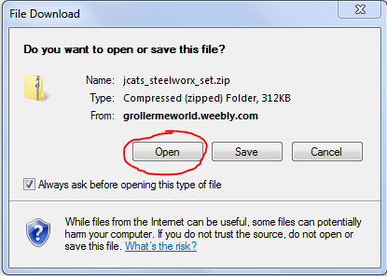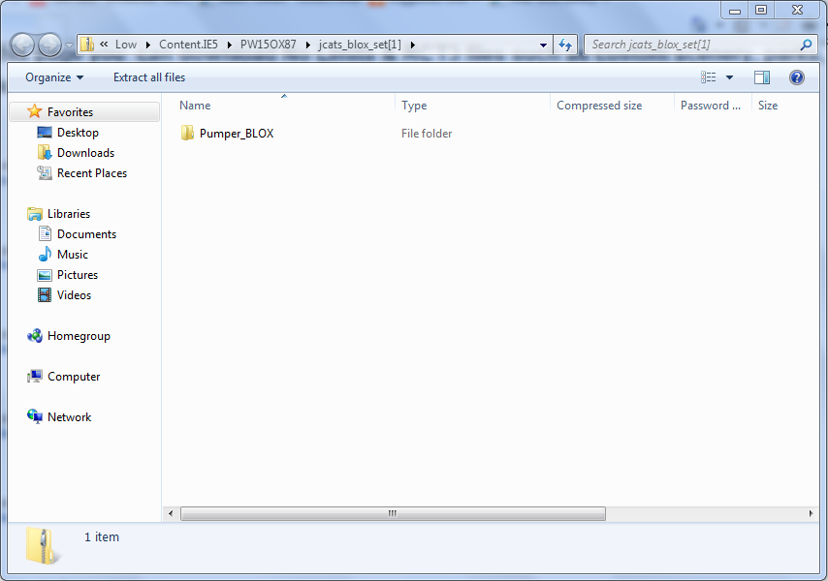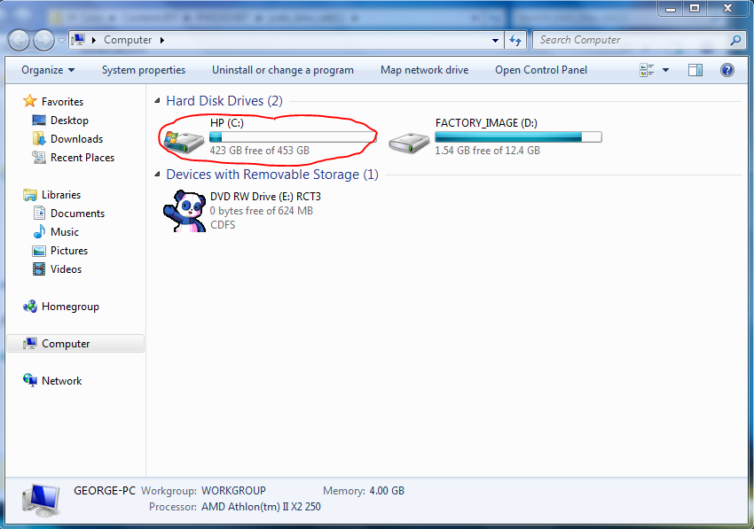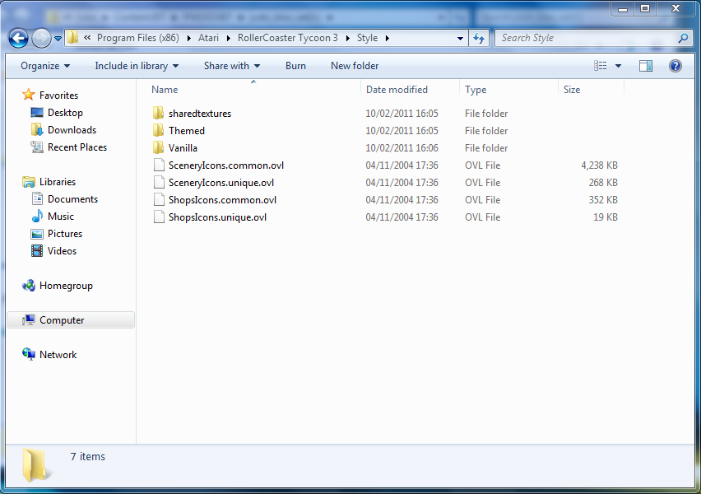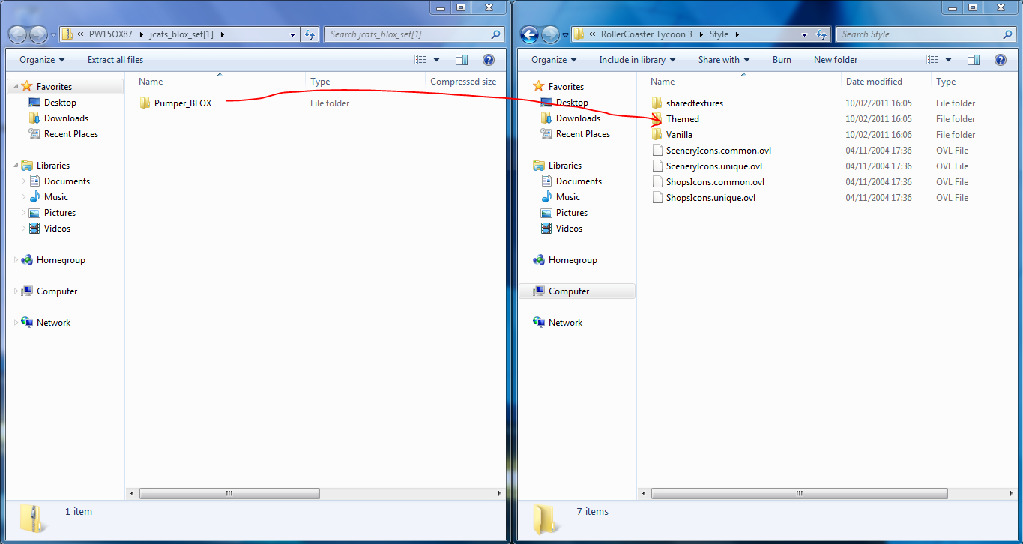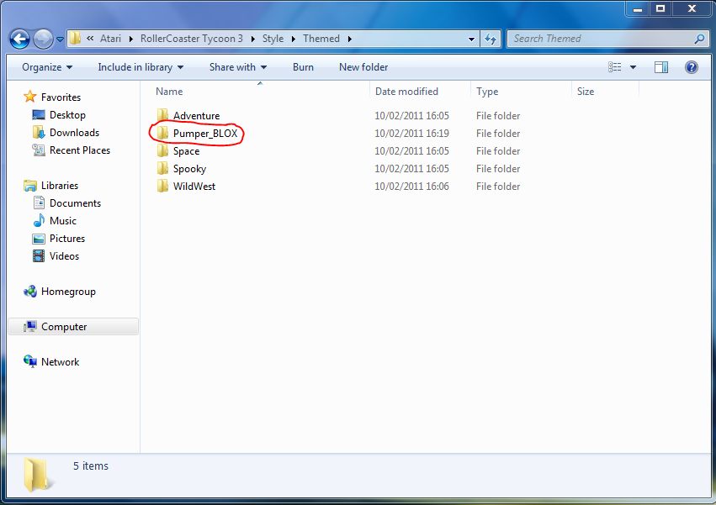er. Leave that up on the screen
Step3: Click on the “start” button, then my computer, then double click on the C drive. Then go to: program files/Atari/roller coaster tycoon 3/ style. You will then see the following seen below:
Step5: Double click on the themed folder to check if the new folder is in there.
And your done!

Note: the basics of Custom scenery (used in this tutorial) can be found in the downloads section of GrollerMe World. For more CS I recommend vodhins comunitypages: http://www.vodhin.org/login.php

Groller

& move onto the next step.

Step4: Drag the file folder from the window in step 2 into the themed folder in the other window.

